#### PONCA TRIBE OF NEBRASKA

*Department of Education*

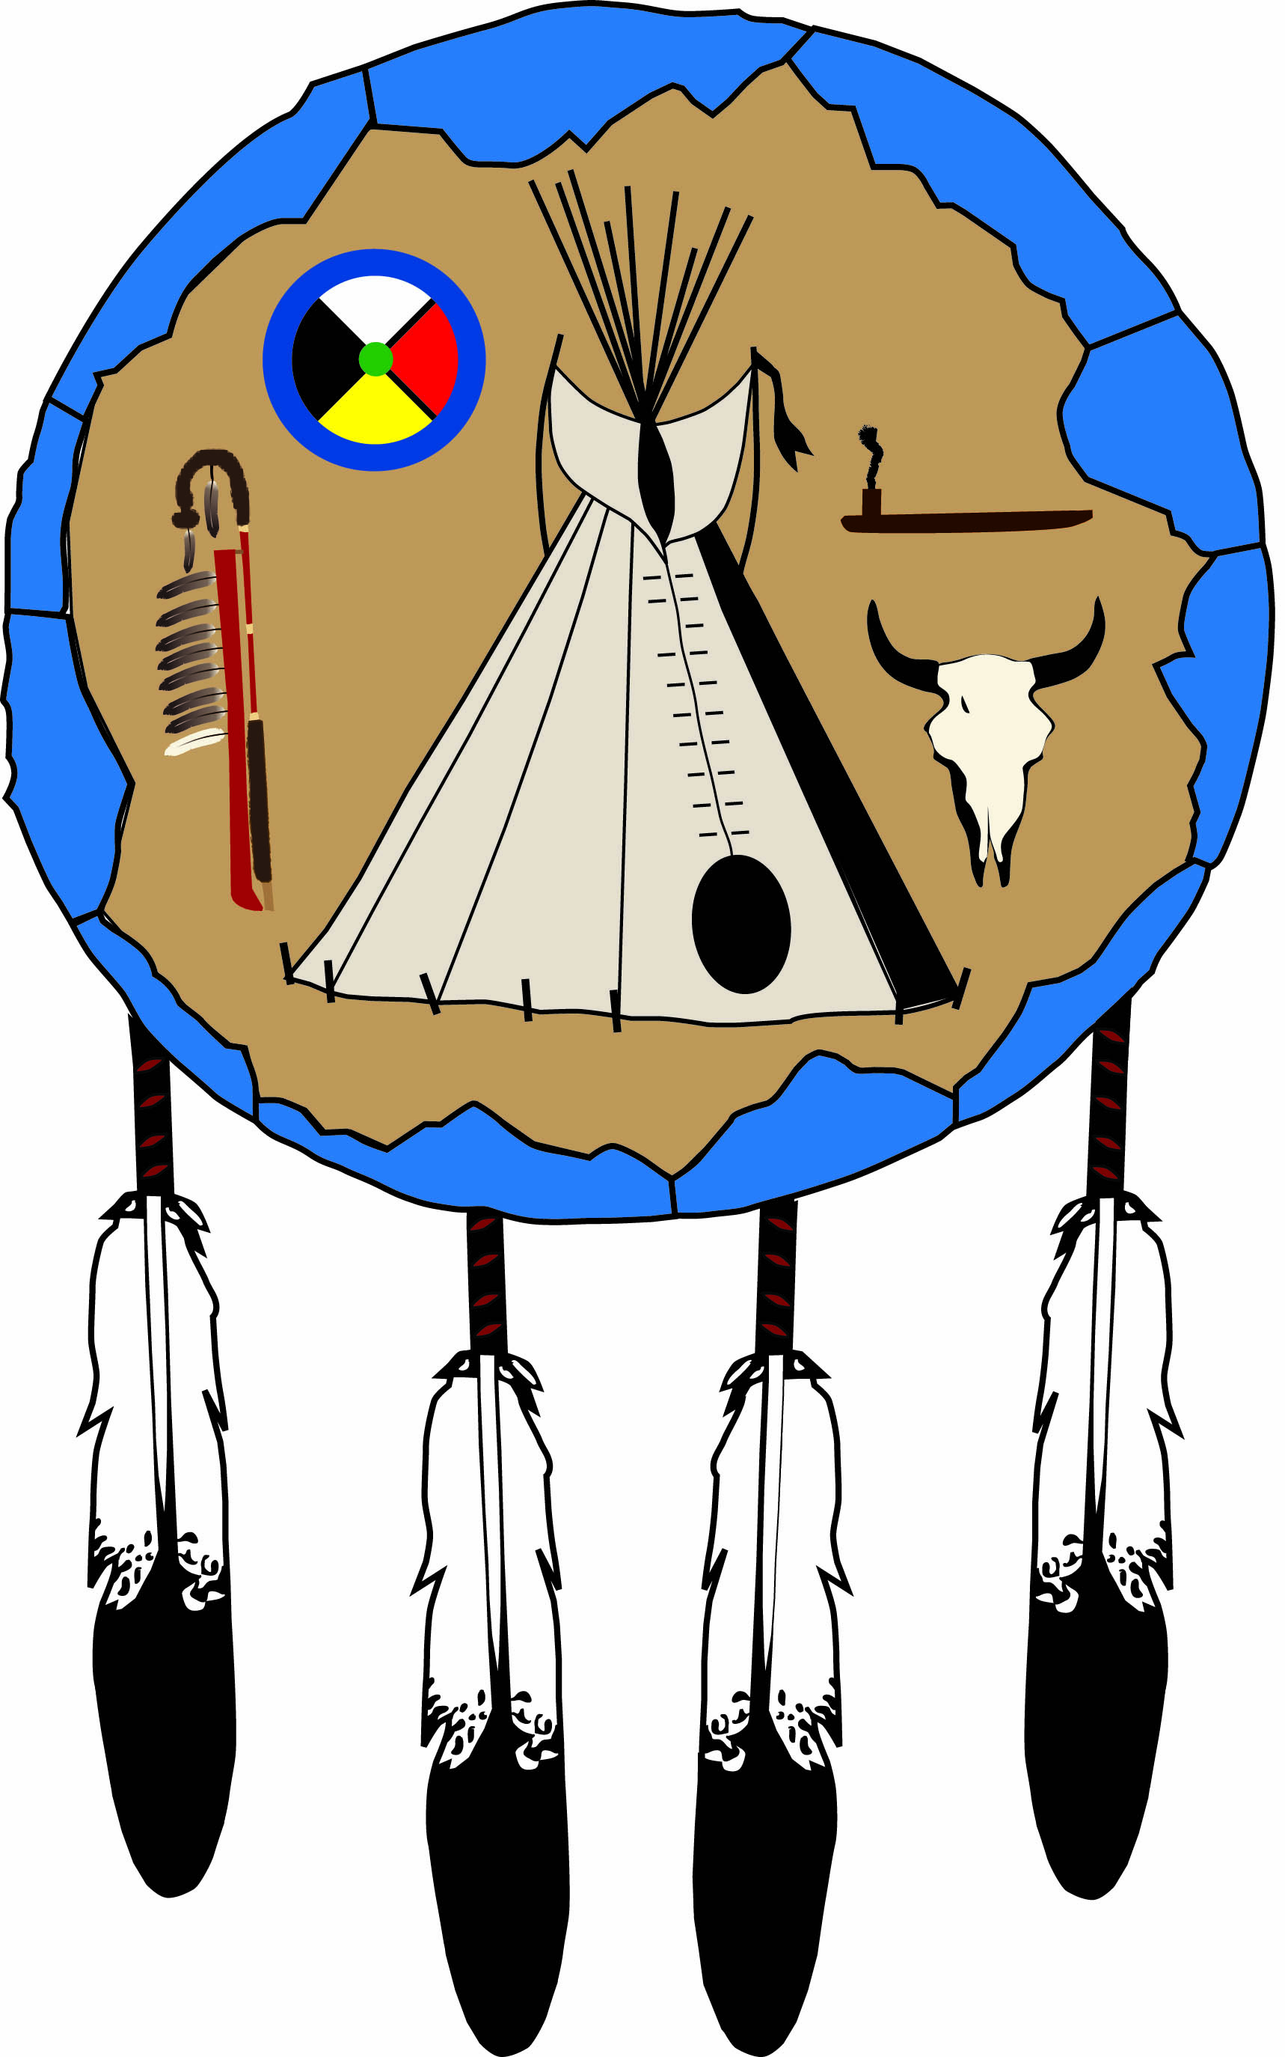

|  |
| --- |
| HIGHER EDUCATION  ADULT VOCATIONAL TRAINING  GRADUATE/POST-GRADUATE  APPLICATION |

**Application Deadlines Are As Followed:**

**Fall: August 15; Winter Quarter: November 15; Spring: December 15; Summer: May 15**

**Pages 5 and 10 are needed by the deadline, NO EXCEPTIONS!!**

Adopted by Tribal Council

April 21, 1997

**PONCA TRIBE OF NEBRASKA**

***Table of Contents***

Required Forms and Deadlines Page 3

Student Checklist Page 4

Application Page 5

Standard Procedures Page 6

General Information/Guidelines Pages 7-9

Contract of Understanding Page 10  
 Certification of Indian Blood (CIB) Page 11

Financial Need Form (FNF) Page 12

Please complete and return all relevant pages of this packet to:  
   
 Ponca Tribe of Nebraska  
 Department of Education  
 1800 Syracuse Avenue  
 Norfolk, NE 68701

**NOTE**: Only the Financial Need Form (FNF)—page 12 of this   
 packet—must be submitted to our office by your school’s Financial   
 Aid Officer (FAO). As the student, you complete the top portion of  
 this form, and the school’s Financial Aid Officer (FAO) is to complete   
 the bottom portion. However, before the Financial Aid Officer (FAO)   
 can complete the bottom section of this form, the results of your Free  
 Application for Federal Student Aid (FAFSA) must be known. The   
 only instances where a FAFSA is not required are the following:   
 (1) short-term certification/licensure programs that are not PELL  
 eligible and (2) graduate programs—although not a PELL eligible   
 program, an assessment of need must still be determined so any  
 relevant areas, including an Expected Family Contribution (EFC)  
 must be indicated.

**PONCA TRIBE OF NEBRASKA**

***Required Post-Secondary Forms***

1. **APPLICATION –** A completed Higher Education/Adult Vocational   
 Training/Graduate/Post-Graduate Application.

2. **CERTIFICATION OF INDIAN BLOOD -** Original with official

seal to verify legal enrollment with the Ponca Tribe of Nebraska.

3. **CONTRACT –** Signed and dated for the relevant year in which  
 assistance is being requested.

4. **FINANCIAL NEED FORM (FNF) -** Students must complete the

Free Application for Federal Student Aid (FAFSA) package in

accordance with the institution’s financial aid policy. The FNF must

be submitted to the school’s Financial Aid Office every academic year   
 and each summer term. Upon completion of the FNF, the school will   
 then forward this form to the Tribe’s Department of Education.

5. **LETTER OF ADMISSION (LOA) -** Undergraduate and graduate

students must be OFFICIALLY and FULLY admitted to a post-

secondary institution which is accredited by one of the six (6) regional

accreditation agencies as recognized by the **Ponca Tribe of Nebraska.**

The graduate applicant shall submit a Letter of Acceptance from the

graduate program of study and a Letter of Acceptance from the

graduate university. The completed Financial Need Form may also  
 function in lieu of this letter.

6. **TRANSCRIPTS** - GED/high school/college transcripts. All first-year

students must submit either a copy of their GED/high school transcript/  
 diploma. On-going students must submit official copies of their college  
 transcripts for the most recent term funded.

**DEADLINES**

**Fall Quarter/Semester:** Application (p5)/Contract (p10) . . . . . . . . . . . . . **August 15**

FNF**/**CIB/Transcript . . . . . . . . . . . . . . . **As soon as possible**

**Winter Quarter:** Application (p5)/Contract (p10) . . . . . . . . . . **November 15**

FNF**/**CIB/Transcript . . . . . . . . . . . . . . . **As soon as possible**

**Spring Quarter/Semester:** Application (p5)/Contract (p10) . . . . . . . . . . **December 15**

FNF**/**CIB/Transcript . . . . . . . . . . . . . . . **As soon as possible**

**Summer Session:** Application (p5)/Contract (p10) . . . . . . . . . . . . . . . **May 15**

FNF**/**CIB/Transcript . . . . . . . . . . . . . . . **As soon as possible**

**Financial Aid and**

**Application Process**

## *Student Checklist*

**Date Sent Date Due What Where**

1.______ **January 31** Pell Grant form Processing Center

2.______ **August 15 (F)** Letter of Admission Ponca Tribe

**November 15 (W)** (LOA) of Nebraska

**December 15 (S)**

**May 15 (SS)**

3.______ **March 1 (F)**  Student Aid Report School FAO **August 15 (W/S)** (SAR)

4.______ **August 15 (F)** Tribal Grant Ponca Tribe

**November 15 (W)** Application of Nebraska

**December 15 (S)**

**May 15 (SS)**

5.______ **15 Days After**  Transcript Ponca Tribe

**End of Term** of Nebraska

6.______ **August 15 (F)** School sends Ponca Tribe

**November 15(W)** Financial Need of Nebraska

**December 15 (S)** Form

**May 15 (SS)**

7.______ **Within 10 Days**  Tribal Grant TO YOU

**of applicable**  Award or Denial

**deadline**

**(F) = Fall Semester (W) = Winter (S) = Spring Semester (SS) = Summer Session**

|  |  |  |
| --- | --- | --- |
| **PONCA TRIBE OF NEBRASKA** | Terms Applying For | |
| *Department of Education* | 20___ Fall | 20___Spring |
| 1800 Syracuse Avenue | 20___Winter | 20___Summer |
| Norfolk, NE 68701  Telephone: 402-371-8834/FAX 402-371-7564  Email: [pate@poncatribe-ne.gov or](mailto:pate@poncatribe-ne.gov%20or) [aknudsen@poncatribe-ne.gov](mailto:aknudsen@poncatribe-ne.gov) | | |

**HIGHER EDUCATION/ADULT VOCATIONAL TRAINING/**

**GRADUATE/POST-GRADUATE APPLICATION**

**Name:_______________________________________________________________________**

Last First Middle Maiden

**Address:______________________________ Telephone:__________________________**

Street (Area Code)

**______________________________________________________________________________**

City State ZIP Email Address (Optional)

**Social Security Number:___________________ Date of Birth:_____________**

**Tribal Enrollment Number: _________________ Sex:**  **Male**  **Female**

Dependent Student  Independent Student (according to federal  
GUIDELINES, students through the age of 24 are generally considered dependent whether or not they reside with their parents.); iF INDEPENDENT, PLEASE CHECK ONE OF THE FOLLOWING:  Single  Married  Separated  Divorced  Widowed

I have completed (Circle one) high school/GED. DATE OF COMPLETION:**_______**

(BE SURE TO INCLUDE A COPY OF YOUR HIGH SCHOOL/GED TRANSCRIPT WITH YOUR APPLICATION.)

School Year for which funding is requested: 20**____** - 20**____**

I am applying for the  Academic Year  Fall  Winter  Spring  Summer

I will be attending  Full-time  Part-time—If part-time, NUMBER Of credit   
hours? **______** Type of term applying for:  Semester  Quarter  trimester

Name and City/State of College selected: **_______________________________________**

this IS a (Circle one) two-year/four-year college? Other:_**_____________________**

College Major**________________________**Expected Date of Graduation **____________**

Expected Degree:  AA/as/aas  BA/bs  MA/MS Other **________________________**

Year in College:  1st  2nd  3rd  4th  Graduate/post-graduate

I will live:  on campus  off campus  with parents.

Have you ever received a Ponca Tribe of Nebraska Educational Grant before? (Circle one) Yes/No. IF Yes, what SCHOOL years?**___________________________________**

No. of semester hours earned:**_________**  No. of quarter hours earned**:__________**

*I declare that I will use any funds I receive through the Ponca Tribe of Nebraska solely for expenses related to my attendance at the above, named college. I further declare that the information submitted as part of the application process is correct to the best of my knowledge, and I give consent to the release of any relevant information to necessary agencies in the completion of my financial aid package. In addition, I will arrange to have an official copy of my grade transcript sent to the Ponca Tribe of Nebraska Department of Education at the end of each academic term. I also grant the Tribe’s Education Department permission to request an official enrollment certificate from the Tribe’s Enrollment Department to verify my eligibility as a tribal member and to update my address with Enrollment if I should relocate.*

***___________________________________________________*____*___ ____________***

Signature of Student Date

**Ponca Tribe of Nebraska**

***Standard Procedures***

Hereinafter, the Ponca Tribe of Nebraska GRANT program shall be called the   
 PROGRAM and the student applicant shall be called the GRANT RECIPIENT.

**ALL APPLICANTS SHALL:**

1. Complete and submit a Ponca Tribe of Nebraska grant

application by August 15 for Fall semester, November 15 for

Winter Quarter, December 15 for Spring Quarter/Semester, and   
 May 15 for summer term.

2. Submit an official Certification of Indian Blood (CIB) by using  
 the same dates indicated in #1.

3. Submit a copy of the Letter of Admission (LOA) from an

accredited college/university/tech school or graduate school

and degree program also using the same dates as those  
 indicated in #1. However, the signature of the Financial Aid  
 Officer on the Financial Need Form (page 12 of this packet)

may serve as a substitute for the Letter of Admission.

4. All first-time applicants must submit copies of their GED/high

school diploma/transcripts. All first-time applicants and all

continuing GRANT RECEPIENTS must submit an official

college transcript within 15 days after the end of each term.

5. The Completed Financial Need Form (FNF) is to be forwarded   
 to our office by the school’s Financial Aid Office. This form   
 should be received at the same time as the application.

**The GRANT RECIPIENT:**

1. The GRANT RECIPIENT shall abide by and comply with

the specific policies, procedures, and eligibility requirements of

the PROGRAM. The GRANT RECIPIENT shall be responsible

for understanding his/her rights and responsibilities regarding

financial assistance including the responsibility to be informed

of program policies.

2. The GRANT RECIPIENT shall sign the application for financial

assistance with the stated terms, conditions, and standards.

3. The GRANT RECIPIENT shall release his/her official academic

grades, graduation date, academic major and type of degree

being pursued.

4. The GRANT RECIPIENT shall immediately report any change  
 in marital status, name, income, enrollment, withdrawal, and/or

transfer status to the PROGRAM. The GRANT RECIPIENT

who misuses said funds shall be denied additional financial   
 assistance awards for one (1) academic year and shall repay

the amount of misused funds.

5. The GRANT RECIPIENT shall notify the PROGRAM of

his/her graduation date, certificate or degree to be conferred,  
 and submit a final grade transcript upon graduation.

6. The GRANT RECIPIENT shall apply for other available grants

and/or scholarships, such as federal, state, and institutional aid

from private/public sources, separate from the PROGRAM.

7. All continuing GRANT RECIPIENTS shall comply with one of

the following academic standards prior to receiving continued

funding:

**a. For full-time undergraduate financial assistance**

i. Academic Term: Earn twelve (12) or more semester

credit hours, or equivalent amount of quarter or

trimester credit hours with a grade point average

(GPA) of 2.0 or higher, including college freshmen

taking remedial courses. Freshmen shall be allowed

to take a maximum of twelve (12) credit hours of

remedial courses, six (6) credit hours per academic

term, including 100 level and below courses within

the first two academic terms;

ii. Eight Week Summer Session: Earn nine (9) or more

credit hours with a grade point average (GPA) of 2.0

or higher; and

iii. Five Week Summer Session: Earn six (6) or more

credit hours with a grade point average (GPA) of

2.0 or higher.

**b. For full-time graduate or post-graduate financial   
 assistance**

i. Academic Term: Earn nine (9) or more semester

credit hours, or equivalent amount of quarter or

trimester credit hours with a grade point average

of 3.0 or higher, or that number of credit hours   
 determined to be full-time by the student’s program  
 of study;

ii. Eight Week Summer Session: Earn nine (9) or

more credit hours or that number of credit hours  
 determined to be full time by the student’s program  
 of study with a grade point average of 3.0 or higher; or  
 that GPA as required by the student’s program of   
 study; and

iii. Five Week Summer Session: Earn six (6) or more

credit hours with a grade point average (GPA) of 3.0

or higher; or that GPA as required by the student’s  
 program of study.

**c. For part-time financial assistance**

i. Undergraduate Program Academic Term:

Earn six (6) to eleven (11) credit hours,

or equivalent amount of quarters or trimester

credit hours with a grade point (GPA) of 2.0

or higher.

ii. Post-graduate Program: Earn up to eight

(8) credit hours with a grade point average

(GPA) of 3.0 or higher.

**THE PROGRAM:**

1. The PROGRAM shall place a GRANT RECIPIENT on

probation if the GRANT RECIPIENT repeated courses

within the minimum twelve (12) credit hours from previous

academic terms while receiving financial assistance and/or

GRANT from the Ponca Tribe of Nebraska GRANT

Program.

2. The PROGRAM shall place a GRANT RECIPIENT

on probation if the GRANT RECIPIENT did not earn

enough credit hours according to applicable standards

during the last academic term and/or completed said with a

grade point average (GPA) below the minimum stated above.

3. The GRANT RECIPIENT who officially or unofficially

withdraws from college or a university may be interviewed and

counseled by the PROGRAM to determine if the reason(s) for

withdrawal is/are justified. If the reason(s) is/are justifiable, the

GRANT RECIPIENT shall be placed on probation. If the

reason(s) is/are not justifiable, the applicant shall be disqualified.

**Ponca Tribe of Nebraska**

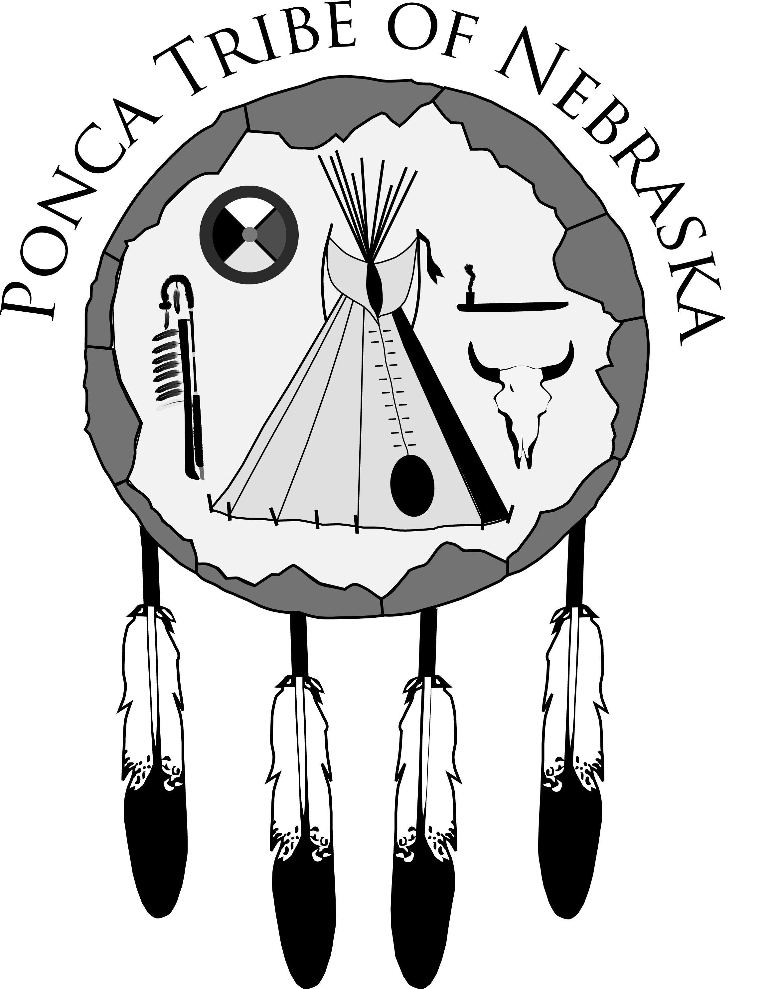

Department of Education

**Contract of understanding**

*Pursuant to Policies and Procedures, Article 5:27, you must sign this contract.*

Upon approval of my application, I, __________________________­­­­­­­­______,  
 (Please print)

shall accept and abide by the conditions stipulated in the terms heretofore   
  
 mentioned and shall be bound by the responsibilities and consequences thereof.   
   
 Conditions and responsibilities I am especially aware of include the following:  
  
 (1) I must maintain the required Grade Point Average set by tribal policy;

(2) I must complete the number of credit hours for which I am funded; and

(3) I shall arrange for an official transcript to be sent to the Ponca Tribe of   
  
 Nebraska Department of Education at the end of each semester/quarter   
  
 for which I am assisted. The cost of the transcript will be my responsibility.

In addition, I grant permission for the Department to receive all financial

information considered relevant to my consideration for funding through  
  
 the Tribe. Financial information may include that information noted on my Free   
  
 Application for Federal Student Aid (FAFSA) and/or my Student Aid Report (SAR).  
  
 However, except for purposes of internal control or a subpoena by a court, the   
  
 Department shall release no information in my file to any third party without my

prior approval.

________________________________________ _____________

Applicant’s Signature Date



**CERTIFICATION OF INDIAN BLOOD**

**REQUEST FORM**

Ponca Tribe of Nebraska

Enrollment Department

P.O. Box 288

Niobrara, NE 68760

The Education Department of the Ponca Tribe of Nebraska is requesting

verification of tribal enrollment for the following applicant who is applying

for a grant.

The following information is herewith submitted:

Name______________________________SS#______________________

Address________________________________________________________

City/State/ZIP_________________________Telephone________________

Date of Birth____________________________________________________

Place of Birth______________________________________________________

Mother’s Maiden Name_____________________________________________

Father’s Name___________________________________________________

Please forward a copy of the applicant’s Ponca Enrollment Office Census

Certificate to:

Ponca Tribe of Nebraska

Department of Education

1800 Syracuse Avenue

Norfolk, NE 68701

Thank you.

__________________________________________

Applicant’s Signature

**HIGHER EDUCATION/ADULT VOCATIONAL TRAINING/**



**GRADUATE/POST-GRADUATE PROGRAM**

**Financial Need Form**

#### I. TO BE COMPLETED BY THE STUDENT:

NAME__________________________________________STUDENT SCHOOL ID#______________________________

HOME ADDRESS___________________________________________________________________________________

CITY/STATE/ZIP_____________________________________TRIBAL ENROLLMENT NO.______________________

YEAR IN COLLEGE_______MAJOR________________MINOR________________CREDIT HRS COMPLETED_____

**Please note:** All undergraduate students are required to complete and process the Free Application for Federal Student Aid (FAFSA) before eligibility for tribal assistance can be determined. The appropriate college/university is then to complete Part II of this form based on the results of the FAFSA and forward to:

**Ponca Tribe of Nebraska**

**Education Department**

**1800 Syracuse Avenue**

**Norfolk, NE 68701**

**Telephone: (402) 371-8834/FAX: (402) 371-7564**

**Email:** [pate@poncatribe-ne.gov](mailto:pate@poncatribe-ne.gov%20) or [aknudsen@poncatribe-ne.gov](mailto:aknudsen@poncatribe-ne.gov)

I, hereby, grant permission for all information on this form to be submitted to the above addressee.

Signature of Student____________________________________________Date_________________________

##### II. TO BE COMPLETED BY THE FINANCIAL AID OFFICER:

This student has applied to the Ponca Tribe of Nebraska Department of Education for assistance. Verified financial need information is required by policy before we can take action on this application. For the undergraduate student, please complete and forward this form or a like form to the above addressee. For the graduate/post-graduate student, complete only those areas that are applicable. Thank you for your assistance.

Budget Period: From___________________to_________________________which starts on ___________

month/year month/year date

This student is considered: Independent____Dependent____Assessed Need . . . . . . . $_________________

|  |  |  |  |  |  |
| --- | --- | --- | --- | --- | --- |
| Parental Contribution | ____________ | PELL Grant | ____________ | Tuition | ____________ |
| Student Contribution | ____________ | Work Study | ____________ | Books | ____________ |
| Spouse Contribution | ____________ | SEOG | ____________ | Fees | ____________ |
| VA Benefits | ____________ | Grant - State/Other | ____________ | Room | ____________ |
| Soc. Sec. Benefits | ____________ | Scholarship | ____________ | Board | ____________ |
| Welfare Benefits | ____________ | Direct Loan | ____________ | Travel | ____________ |
| Voc Rehab | ____________ | Unsub Loan | ____________ | Misc. | ____________ |
| Workforce Dev | ____________ | Waivers/Other | ____________ |  |  |
| Total | ____________ | Total | ____________ | Total | ____________ |

We recommend that the Ponca Tribe of Nebraska consider awarding this student . . . . . . . ______________

Signature_______________________________________________________________________________

Financial Aid Officer* Date Telephone Number

___________________________________________________________________________________________________________

Name of College Address ZIP Code

*My signature verifies that the above named student has been accepted by our college for the period indicated.

Terms implemented by your college/university: 🞎 Semesters 🞎 Quarters 🞎 Trimesters 🞎 Other: _________

Tuition and fee costs are based on: 🞎 12 credit hours per term 🞎 15 credit hours per term 🞎 Other: _________