
1800 Syracuse Avenue PHONE: 402-371-8834

Ponca Tribe of Nebraska
Department of Education
Norfolk, NE 68701 FAX: 402-371-7564
Email: aknudsen@poncatribe-ne.gov

BUILDING FOR THE FUTURE SCHOLARSHIP

Dear Tribal Member:

This is to inform you of a new scholarship that is now available to our members nationwide. This scholarship was made possible by a private donor who wishes to remain anonymous. Currently, the amount of the scholarship is $1,000.00; and the student must demonstrate “need.” Also, depending on the student’s “need,” this scholarship may be awarded in conjunction with tribal assistance or independent of tribal assistance.

The deadline to submit for consideration of this scholarship is August 15TH EVERY school year.

All applications must be completed and received by this date. Names will then be entered in a drawing. And once the name of the winner is known, he or she will be notified immediately.

Attached are the guidelines and relevant forms that need to be completed. Please review the materials, and if you have any questions, please contact Aubrey or me.
Sincerely,

Pat Eichberger
Pat Eichberger Director of Education

Enclosure: Guidelines, Application, Contract, Financial Need Form

BUILDING FOR THE FUTURE
Guidelines

Purpose:
These funds are to be awarded to a Ponca student who demonstrates need with his/her career development.

Selection:
- All eligible students will be identified.
- On August 15th of the relevant school year, a drawing will be held; and
- The student whose name is drawn will be awarded the scholarship.

Provisions:
- The student must have his/her paperwork complete by the August 15th deadline:
- If awarded, funds will go directly to the school and will be applied to the student’s “unmet need.”

Eligibility
- The student must be enrolled in some type an Adult Vocational Training Program or working toward a bachelor’s degree.
- The student must provide proof of enrollment in the Ponca Tribe of Nebraska
- The student must provide proof of graduation from high school or completion of his/her GED.
- The student must complete and submit the following forms:
  - Application;
  - Contract; and
  - Financial Need Form

Requirements:
- The student must maintain satisfactory academic progress with an accumulative GPA of 2.5 or better for the term funded.
- If the student does not maintain the required 2.5 GPA, he/she must refund the scholarship.
- The student must also submit an official transcript to the Ponca Tribe of Nebraska Department of Education for the term funded.
BUILDING FOR THE FUTURE
Application
Student Information
Name:
Address:
City: | State: | ZIP Code:
Phone: | Cell Phone: | Email Address:
Date of Birth: | SS#: | Tribal ID#:
Please answer the following questions
Name of college/trade school you plan to attend:
Program of Study:
Cost of Program:
Cost for which the scholarship will be used:
Term(s) for which funds are being requested:
Please include the following attachments
Proof of enrollment in the Ponca Tribe of Nebraska
Proof of completion of either high school or GED
A completed Financial Need Form
Signed contract
Signature
Signature: |  | Date:

BUILDING FOR THE FUTURE
Contract of Understanding

I, , will use this scholarship to assist me with
Please print full name
my career development. I also understand that I am to maintain satisfactory progress with a cumulative GPA of 2.5 or better and will provide the Ponca Tribe of Nebraska Department
of Education with a transcript after completion of each term for which the scholarship is to be used. If I do not maintain satisfactory progress, I will reimburse the funds that I received.

Scholarship Recipient Date

Note: This scholarship was gifted to the Ponca Tribe of Nebraska by a donor who wishes to remain anonymous and whose main request is that the award be used in its entirety to assist a need-based student with his/her career development needs.
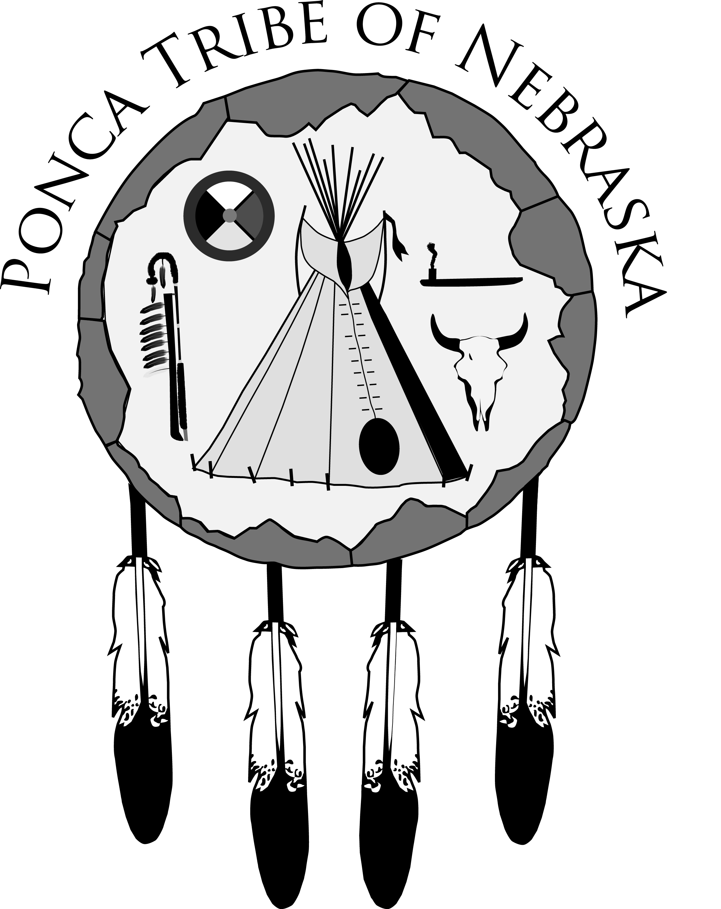
HIGHER EDUCATION/ADULT VOCATIONAL TRAINING/
GRADUATE/POST-GRADUATE PROGRAM
All SCHOLARSHIPS FINANCIAL NEED FORM

I. TO BE COMPLETED BY THE STUDENT:

NAME______________________________________________SCHOOL ID#________________________________

HOME ADDRESS________________________________________________________________________________

CITY/STATE/ZIP__________________________________________TRIBAL ENROLLMENT NO.__________________

YEAR IN COLLEGE_______MAJOR__________________MINOR________________CREDIT HRS COMPLETED______

Please note: All undergraduate students are required to complete and process the Free Application for Federal Student Aid (FAFSA) before eligibility for tribal assistance can be determined. The appropriate college/university is then to complete Part II of this form based on the results of the FAFSA and forward to:
Ponca Tribe of Nebraska Education Department
1800 Syracuse Avenue
Norfolk, NE. 68701
Telephone: (402) 371-8834 FAX: (402) 371-7564 Email: pate@poncatribe-ne.gov or aknudsen@poncatribe-ne.gov

I, hereby, grant permission for all information on this form to be submitted to the above addressee.

Signature of Student_______________________________________________Date_________________________

II. TO BE COMPLETED BY THE FINANCIAL AID OFFICER:

This student has applied to the Ponca Tribe of Nebraska Department of Education for assistance. Verified financial need information is required by policy before we can take action on this application. For the undergraduate student, please complete and forward this form or a like form to the above addressee. For the graduate/post-graduate student, complete only those areas that are applicable. Thank you for your assistance.

Budget Period: From_____________________to__________________________which starts on _____________
month/year month/year date
This student is considered: Independent______Dependent______Assessed Need . . . . . . . $__________________

SAI (replaces EFC) | ____________ | PELL Grant | ____________ | Tuition | ____________
VA Benefits | ____________ | Work Study | ____________ | Books | ____________
Soc Sec Benefits | ____________ | SEOG | ____________ | Fees | ____________
VA Benefits | ____________ | Grant - State/Other | ____________ | Room | ____________
Soc. Sec. Benefits | ____________ | Scholarship | ____________ | Board | ____________
Workforce Dev | ____________ | Direct Loan | ____________ | Travel | ____________
State Scholarship | ____________ | Unsub Loan | ____________ | Misc. | ____________
State Ind Scholarship | ____________ | Waivers/Other/Specify | ____________
Total | ____________ | Total | ____________ | Total | ____________

We recommend that the Ponca Tribe of Nebraska consider awarding this student . . . . . . . _________________

Signature_____________________________________________________________________________________
Financial Aid Officer* Date Telephone Number

___________________________________________________________________________________________________________________
Name of College Address ZIP Code

*My signature verifies that the above named student has been accepted by our college for the period indicated.

Terms implemented by your college/university: Semesters Quarters Trimesters Other: _____________
Tuition and fee costs are based on: 12 credit hours per term 15 credit hours per term Other: ___________

